**Online Task Management System Project Report**

**Introduction:**

“Online Task Management System” project is a project where a manager/boss can assign a task to its employees and employee can see the task assigned to his/him. The main purpose of the project is to provide an online system for managing tasks in an office or organization. This Online Task Management system provide an online system to replace the existing manual task management system.

This system is implemented to provide a smooth system for managing tasks in an office or organization. We have implemented the system in such a way that an admin can online assign tasks to its employees and track its status too. No prior knowledge of any language is needed to use the system.

Every organization or offices use a manual system to assigning and managing tasks. So, this project is made to replace this existing process of managing task. It makes the process easy and paperless.

**Software used:**

We have used following basics software for the project –

1. Text editor (Atom)
2. Web browser (Google Chrome)
3. Xammp local server

**Language used**

Frontend languages -

1. HTML
2. CSS
3. Bootstrap

Backend languages –

1. PHP
2. JavaScript
3. jQuery
4. MySQL

**About the project:**

In the project “Online Task Management System” we have implemented the basic activities of an organization or office like assigning task to users and get the status of the task and approve leave etc.

In this project a user can view tasks assigned to him/her. He can update the status of the task assigned to him. Likewise, an admin can view all the assigned tasks with their status. He can delete or edit all the tasks assigned.

In this project we have provide two panel –

1. User panel
2. Admin panel

**User panel –**

To access user panel, a user has to registered, if he/she is registered it may login to the system and access the user panel or user dashboard. In the user dashboard a user can do activities like –

1. View assigned task
2. Update task’s status
3. Apply for leave
4. Check leave status
5. Logout

User login details –

Email id – [test@gmail.com](mailto:test@gmail.com)

Password – test@123

You may also register a new user and login to access the user panel.

**Admin panel –**

To access admin panel, one has to login using admin’s login details. Once logged in as an admin, admin can do some basic activities like –

1. Create a new task
2. Edit a task
3. Delete a task
4. View all the leave applications
5. Approve or reject a leave
6. Logout

Admin login details –

Email id – [admin@gmail.com](mailto:admin@gmail.com)

Password – admin@123

**Database details –**

To store the related data, we have created a database named “tms_db”. In this database we have created many tables to store the data like user’s data, task data and leave related data.

**Schemas –**

1. User Schema –

users (uid, name, email, password, mobile);

1. Task Schema –

tasks (tid, uid, description, start_date, end_date, status);

1. Leaves Schema –

leaves (lid, uid, subject, message, status);

1. Admin Schema –

admins (id, name, email, password, mobile);

**ER diagram -**

**leaves**

**Users**

**Apply**

**Assigned**

**Tasks**

**DFD diagram –**

**Get leave applications**

**Get leave status**

**Get task status**

**Update task**

**Admin**

**USER**

**Assign task**

**Get tasks**

**Update leave status**

**Apply leave**

**Some Snapshots from the project –**

**Login Page –**

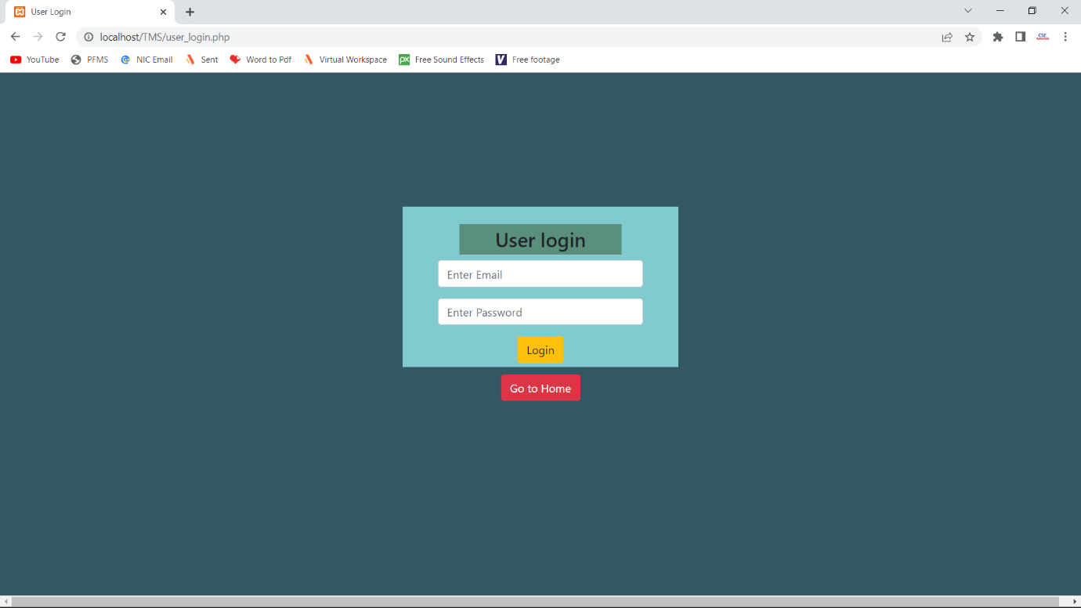

**Registration Page -**

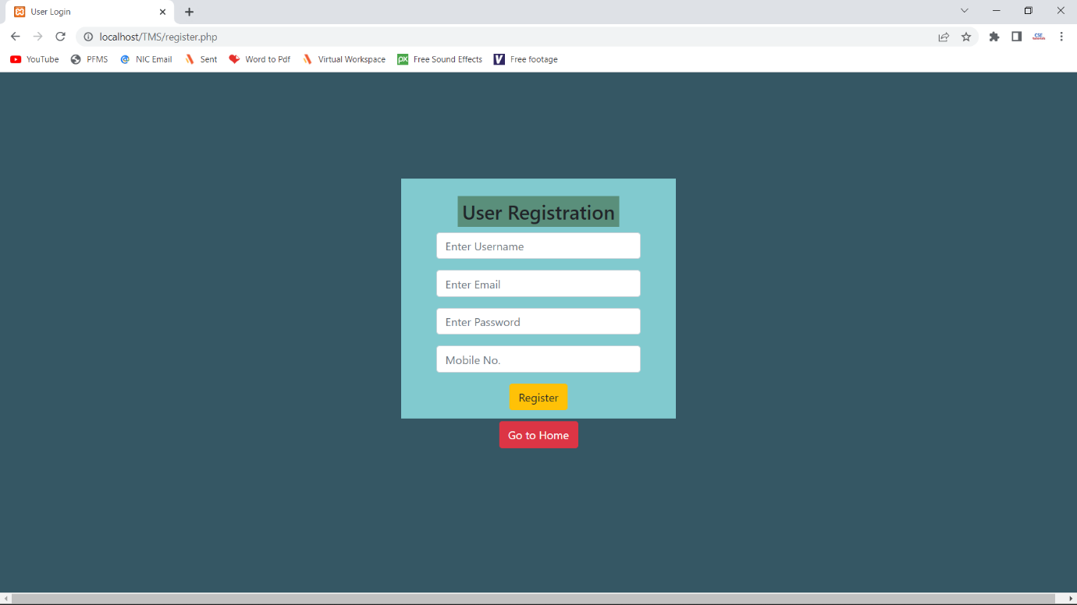

**Update Task Page –**

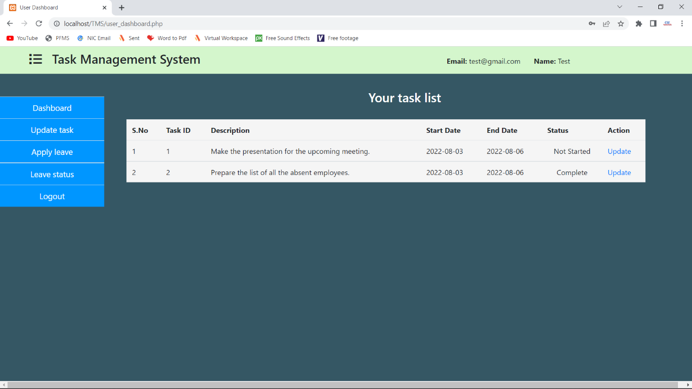

**Apply leave Page -**

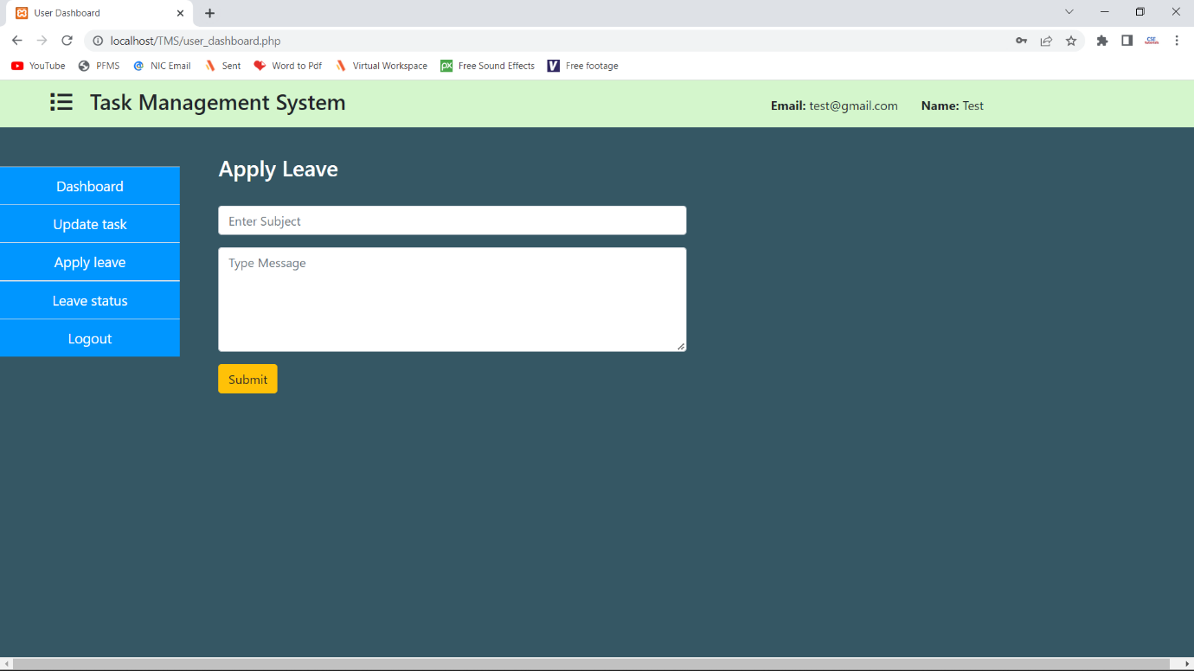

**Create task Page –**

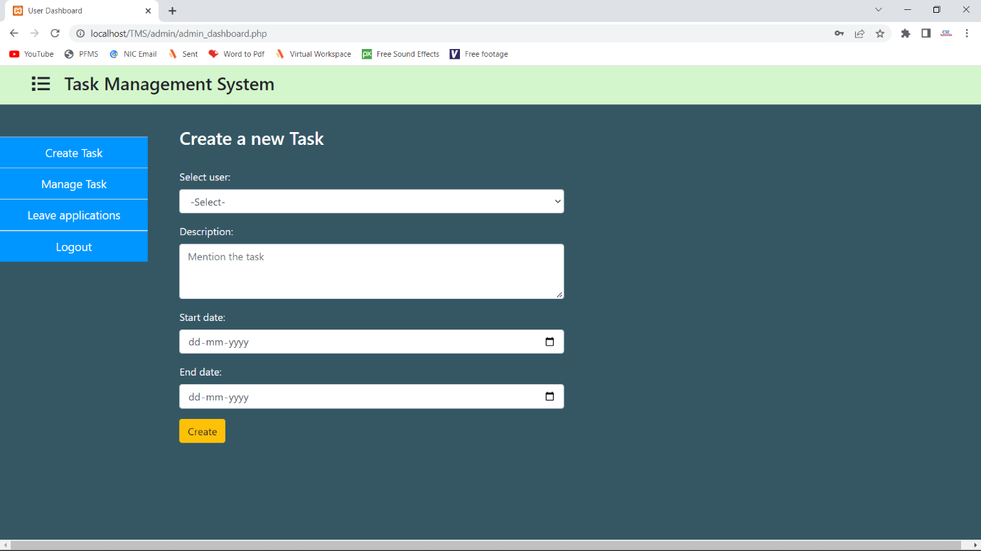

**Edit/Delete task Page -**

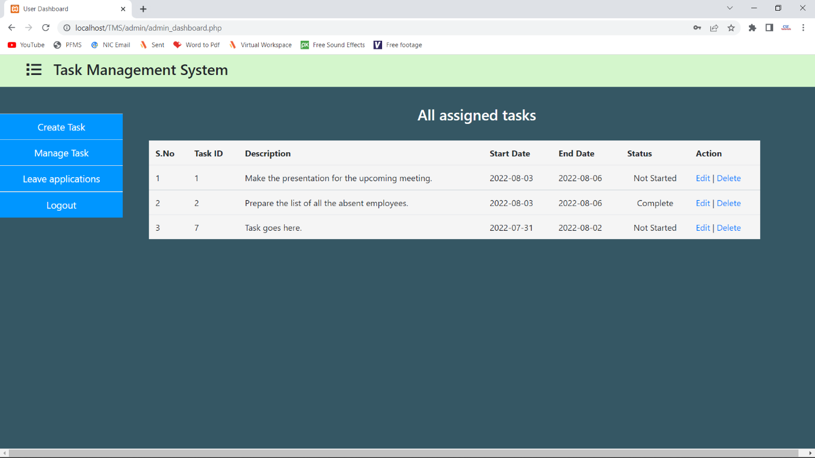

**Approve/reject leave Page –**

